**A454-Afr-Benin-Bell-Court style-Nigeria-18th century**

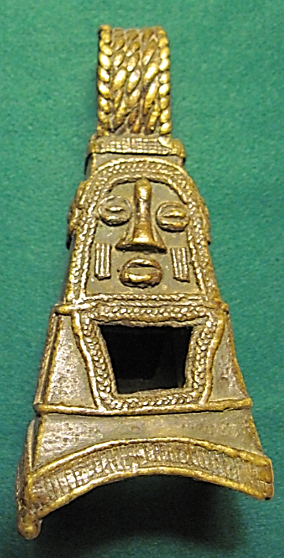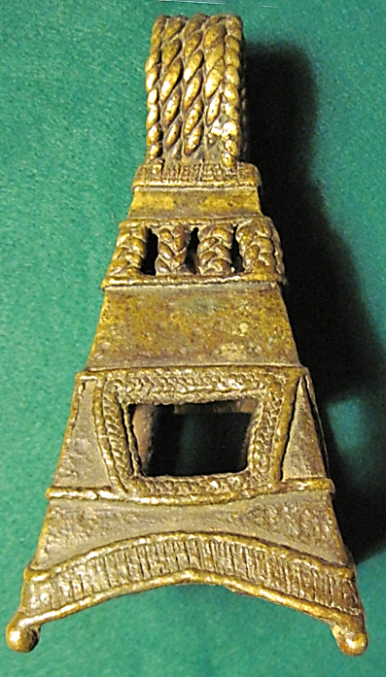

Figs. 1-2. Benin-Bell-Court style-Nigeria-18th century

**Case no.: 6**

**Accession Number: A454**

**Formal Label:** Benin-Bell-Court style-Nigeria-18th century

**Display Description:**

This type of bell, identified by its distinctive four-sided, flat-topped shape, was once placed on an ancestral altar in the royal palace. Its shape is thought to resemble the palace roof turrets. Benin warriors wore smaller versions of these bells on their chests, as can be seen on the plaques that formerly covered the piers in the palace courtyard. The sound of the bells identified Benin warriors in battle, served as a sign of the spiritual protection of the king, and spread terror among the enemy

**LC Classification:** N7399

**Date or Time Horizon:** 18th century

**Geographical Area:** Djougou, Benin

**Map:**

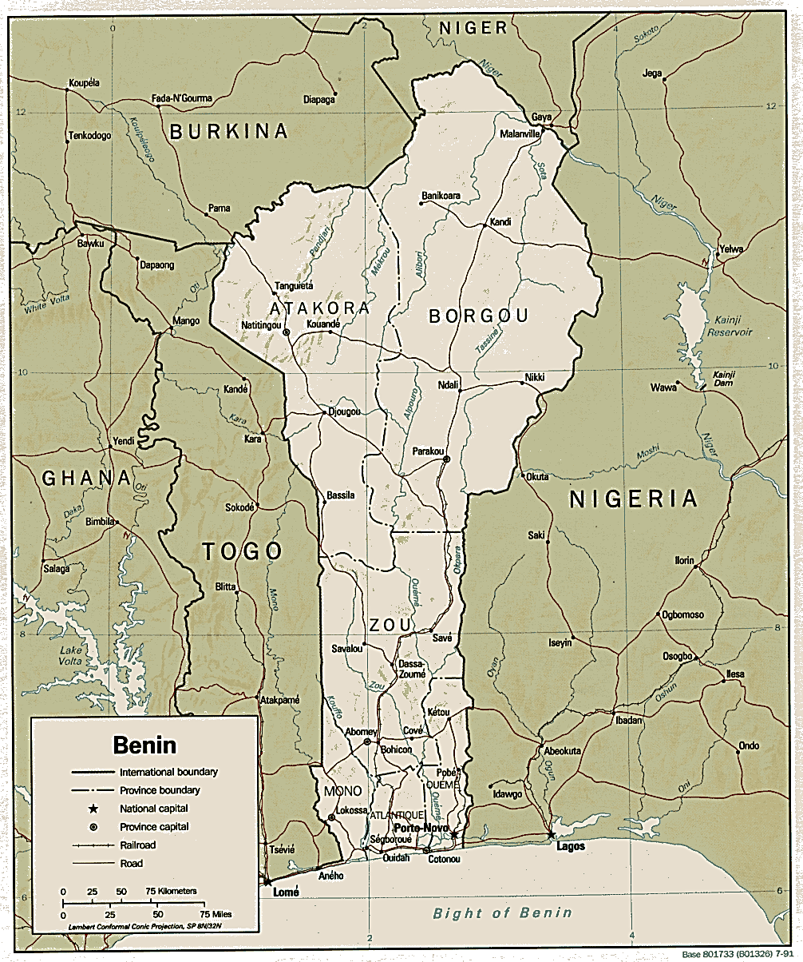

[**https://www.africa.upenn.edu/CIA_Maps/Benin_19841.gif**](https://www.africa.upenn.edu/CIA_Maps/Benin_19841.gif)

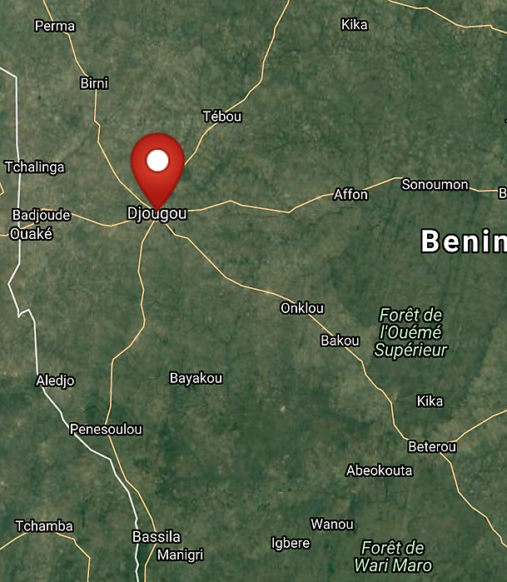

**Map of Djougou. Benin. After http://latitude.to/map/ng/nigeria/cities/benin-city**

**GPS coordinates: 9º42'34.67" N 1º40'4.42" E**

**Cultural Affiliation:** Djougou, Benin

**Media:** Copper alloy, iron

**Dimensions:** H 161.86 mm, 6.66 in

**Weight:** 706 g, 1 lb 8 7/8 oz

**Condition: original**

**Provenance:** One of these bells was given by Joseph H. Hirshhorn to the Smithsonian Institution in 1979, 85-19-22

**Discussion:**

**References:**

Dark, Philip J. 1973. *An introduction to Benin art and technology*. Oxford, Clarendon Press.

.